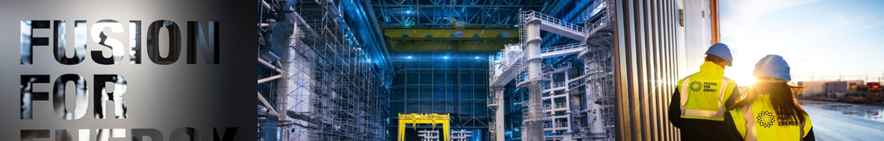

Fusion for Energy Technology Transfer Award 2022 – Proposal Template and guidelines
As part of the efforts to promote the use of fusion technologies and know-how, Fusion for Energy and In Extenso Innovation Croissance have launched a contest to highlight and reward achieved or on-going projects which integrate fusion solutions in other applications.
The proposal shall be submitted in English and not contains more than 3 pages (annexes excluded) following the template and guidelines described in this document.
Summary of the proposal
Contact Details
Applicant (name of the organisation) | Fill in here
Contact details (email and phone number) | Fill in here
Signatory name and job title and signature | Fill in here

Summary of the technology transfer case study
- 10 lines maximum summarising the technology transfer case study in a non-fusion market based on a fusion technology. It can be an ongoing technology transfer project or a planned project to be carried out in a non-fusion market.
- This prize rewards the commercial use of a fusion technology in a non-fusion market.
Commercial use of the fusion technology and business potential
Description of the use made or planned to be made of a fusion technology in a non-fusion market
- Describe the business case
Evaluation of the market potential
- Evaluate the market potential of the technology (market volume, customers, time to market if the commercial use is not consolidated yet, etc.) in the non-fusion market
Description of the technology transfer case study/business case
Fusion technology used or to be used
- Name of the fusion project and description of the fusion technology used or to be used in the technology transfer project.
Description of the effort (investment/resources/actions/activities) made or planned to be made to achieve the use of a fusion technology in non-fusion market
- Indication of the investment, resources allocated and/or actions and activities done, in preparation, or intended to be done in order to bring the fusion technology into the market. E.g. feasibility study, field tests, market analysis, business deals with third companies ongoing or closed, Intellectual Property protection, FTO studies, etc.
Socio-economic impact of the technology transfer case
- Revenue growth, increase in sales, opening of new business, job creation, etc.
- Which positive effect did it have for the non-fusion application? Faster production, cost reduction, better product, increased sales, higher safety of operations, energy savings, etc.
- In case of planned use of the fusion technology in a non-fusion market, describe the socio-economic potential impact.

Contacts:
Nicolas LOUEE – Technology Transfer Broker – nicolas.louee@inextenso-innovation.fr
Carmen Casteras – F4E Intellectual Property & Technology Transfer Officer carmen.casteras@f4e.europa.eu

